**MODULE: 1 (SDLC)**

**• What is software? What is software engineering?**

Software is a set of instructions, data or programs used to operate computers and execute specific tasks. It is the opposite of hardware, which describes the physical aspects of a computer. Software is a generic term used to refer to applications, scripts and programs that run on a device…

Software engineering is the process of developing, testing and deploying computer applications to solve real-world problems by adhering to a set of engineering principles and best practices...

**• Explain types of software**

There are Three types software

1.programing software….

2.System Software…

and

3.Application Software…

**1.Programing Software**

It is a set or collection of tools that help developers in writing other software or programs. It assists them in creating, debugging, and maintaining software or programs or applications. We can say that these are facilitator software that helps translate programming language such as [Java](https://www.javatpoint.com/java-tutorial), [C++](https://www.javatpoint.com/cpp-tutorial), [Python](https://www.javatpoint.com/python-tutorial), etc., into machine language code. So, it is not used by end-users. For example, compilers, linkers, debuggers, interpreters, text editors, etc. This software is also called a programming tool or software development tool….

**2.System software**

is the main software that runs the computer. When you turn on the computer, it activates the hardware and controls and coordinates their functioning. The application programs are also controlled by system software. An operating system is an example of system software….

operating system is the system software that works as an interface to enable the user to communicate with the computer. It manages and coordinates the functioning of hardware and software of the computer. The commonly used operating systems are Microsoft Windows, [Linux](https://www.javatpoint.com/linux-tutorial), and Apple Mac OS….

**3.Application software**

is a set of programs designed to perform a specific task. It does notcontrol the working of a computer as it is designed for end-users. A computer can run without application software. Application software can be easily installed or uninstalled as required. It can be a single program or a collection of small programs. Microsoft Office Suite, Adobe Photoshop, and any other software like payroll software or income tax software are application software….

**• What is SDLC? Explain each phase of SDLC**

SDLC It stands for Software Development Life Cycle models. SDLC – is a continuous process, which starts from the moment, when it’s made a decision to launch the project. There is no one single SDLC model. They are divided into main groups, each with its features and weaknesses….

requirement analysisthe process discuss the **requirements for the final product.** The goal of this stage is the detailed definition of the system requirements. Besides, it is needed to make sure that all the process participants have clearly understood the tasks and how every requirement is going to be implemented….

Designing project architecture at the second phase of the software development life cycle, the developers are actually designing the architecture. here are defined the technologies used in the project, team load, limitations, time frames, and budget. The most appropriate project decisions are made according to the defined requirements…..

Development and programming After the requirements approved, the process goes to the next stage – actual development. Programmers start here with the source code writing while keeping in mind previously defined requirements. The system administrators adjust the software environment, front-end programmers develop the user interface of the program and the logics for its interaction with the server.The programming by itself assumes four stages….

TestingThe testing phase includes the debugging process. All the code flaws missed during the development are detected here, documented, and passed back to the developers to fix. The testing process repeats until all the critical issues are removed and software workflow is stable…..

DeploymentWhen the program is finalized and has no critical issues – it is time to launch it for the end users. After the new program version release, the tech support team joins. This department provides user feedback; consult and support users during the time of exploitation. Moreover, the update of selected components is included in this phase, to make sure, that the software is up-to-date and is invulnerable to a security breach…..

**• What is DFD? Create a DFD diagram on Flipkart**

Data Flow Diagram It's easy to understand the flow of data through systems with the right [data flow diagram software](https://www.lucidchart.com/pages/examples/data-flow-diagram-software). This guide provides everything you need to know about data flow diagrams, including definitions, history, and symbols and notations. You'll learn the different levels of a DFD, the difference between a logical and a physical DFD and tips for making a DFD….

DFD Diagram on flipkart abow….

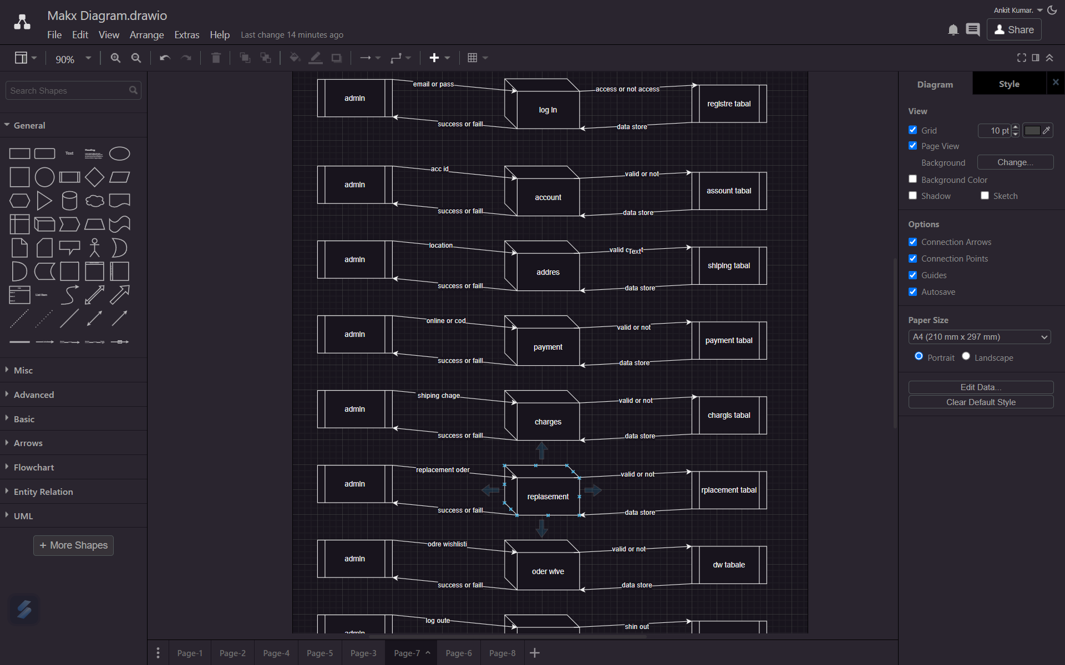

**• What is Flow chart? Create a flowchart to make addition of two numbers**

a **flowchart** is a graphical representation of a procedure or algorithm in the form of a diagram. You can convert a complex process into a bright and straightforward method using a flowchart and make it understandable. Besides, if you need to frame a flowchart, you do not need a professional. Instead, you can create it in your way…

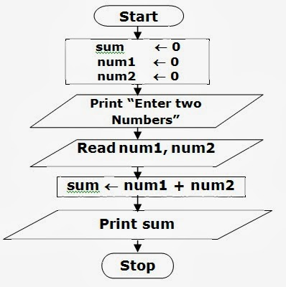

• What is Use case Diagram? Create a use-case on bill payment on paytm.

A **flowchart** is a graphical representation of a procedure or algorithm in the form of a diagram. You can convert a complex process into a bright and straightforward method using a flowchart and make it understandable. Besides, if you need to frame a flowchart, you do not need a professional. Instead, you can create it in your way. Flowchart symbols like a diamond, round, parallelogram, give life to a dead diagram….

